**Design Document-ASSIGNMENT-3**

**IMT2023013-AREEN PATIL**

**UML Diagram:**

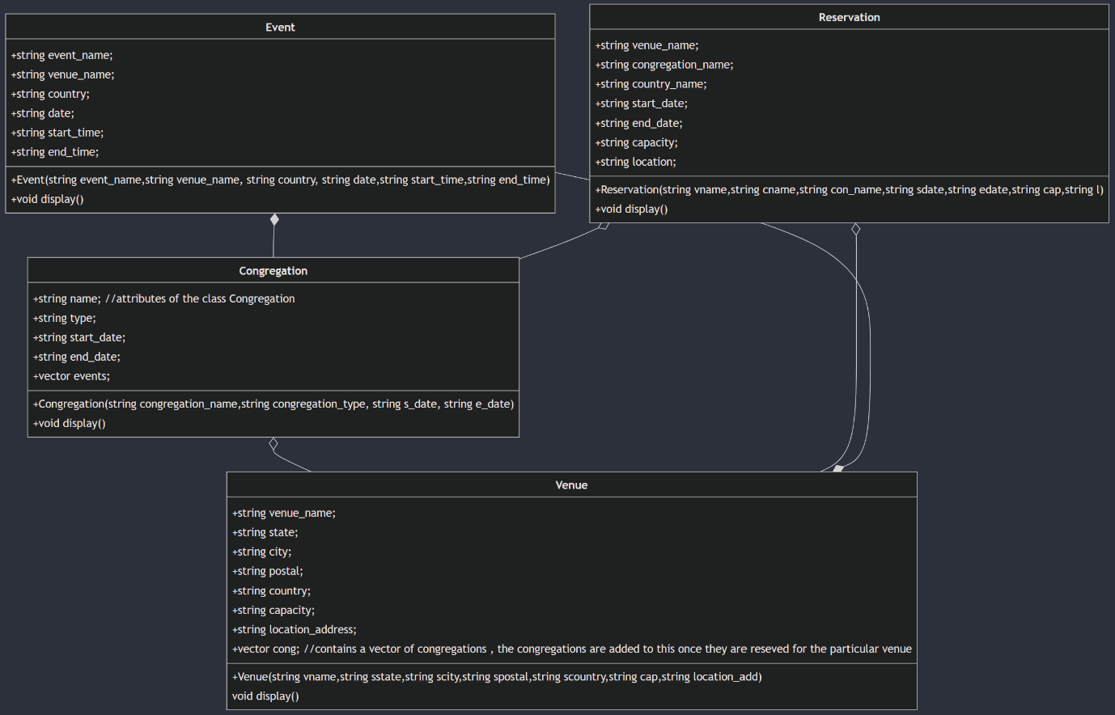

Classes:

Venue, Event, Congregation and Reservation

Relationship between the different classes:

**Venue and Congregation**:

* **Relationship Type**: **Aggregation.**
* This is aggregation because Congregation can exist without Venue.

**Congregation and Event**:

* **Relationship Type**: **Aggregation**
* The Event objects exist independently of the Congregation

**Reservation and Venue**:

* **Relationship Type**: **Association**
* The relationship here is a simple association, as the Reservation knows about the Venue, but does not control its existence or lifecycle.

**Reservation and Congregation**:

* **Relationship Type**: **Association**
* Similar to the relationship between Reservation and Venue, Reservation references a Congregation by name, indicating a simple association without ownership or lifecycle control.

Main Functions/Commands:

Add_Venue(): adds the venue to the venue list.

Show_Venue(): prints the list of all the added venues.

delete_Venue(): delete the venue from the venue list.

Add_Event(): adds the event to the particular venue and congregation

Delete_Event(): delete the event

Show_Events(): print the lisi of the events at the venue

Add_Congregation(): adds the congregation to the list

Delete_Congregation(): delete the congregations from the list and from the venue list.

Show_Congregation(): prints the list of all the congregatiosn along with their dates.

Free_Venue(): free the venue and delete all its reservations with the congregations

Show_reserve(): print all the reservations

Helper Functions:

daysBetwen(), dateDifference(), dateDifference(), date_comparator(), leap_year_chekcer(), date_verifier(), start_end_verifier(), date_diff(), time_diff().

I have created these helper functions in order to find the difference in the dates and also find the if some date is valid or if some interval of date is valid , also if some time is valid or not.

Main(): This function mainly contains the strings and the string parsing inorder to take the input from the user. There are multiple if conditions to check if the input is given in the wrong format then the error is printed . The code can take the input both from the flle as well as the terminal , this is achieved using the input_stream and the file object.

Design Thinking:

There is a list of venues namely venue_list , this list contains and stores all the venues, each venue has an attribute for the congregation and each of the congregations has a vector for events, which contains all the events which are in that particular venues for that congregation.Also there is a vector / list for the reservations namely reserves which stores all the reservations to the reserves vector .There is also a separate vector for the congregations namely the congregation_list this is so because the venue and congregations can also exists separately. In this way we can store the venues and the congregations in the venue_list and add only the congregation when a reservation is mafe for that venue.

Whenever a function is called the vector are passed by using a & , so that the changes are reflected it the main function also.